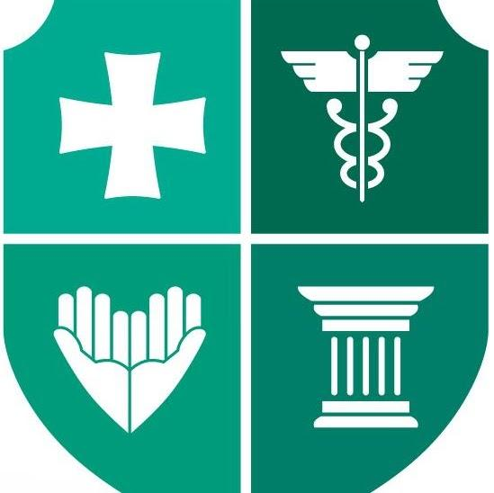
Official Statement on Novel Coronavirus

Travel to Georgia is in the low-risk zone for the spread of coronavirus. There are currently no confirmed cases in Georgia or of Georgian citizens abroad, and the risk to the public is low. The government is monitoring the situation closely and will continue to actively work with the World Health Organization (WHO) and the international community.
The Government of Georgia, including the Ministry of Internally Displaces Persons from the Occupied Territories, Labor, Health and Social Affairs and the National Center for Disease Control and Public Health are taking measures to prevent the spread of coronavirus.
With this, there is a screening procedures for passengers travelling from China to Georgia. Georgian public health workers are monitoring passengers as well as providing them with useful information on the symptoms of the virus upon arrival. Herewith, the government has issued clinical guidance for the detection and diagnosis of novel coronavirus. Special brochures elaborated with the World Health Organization (WHO) are translated into three languages to be distributed for incoming tourists, especially from China.
If you traveled to People’s Republic of China and experience following symptoms within last 2 weeks:

- fever
- cough
- difficulty breathing
In case you experience the above-mentioned symptoms please call:
15 05 (24/7) Ministry of Internally Displaced Persons from Occupied Territories, Health, Labor and Social Affairs
116 001 (Monday to Friday, 10:00-17:00) National Center for Disease Control and Public Health
(Telephone # of Chinese embassy) – For information in Chinese
+995 599 65 05 85 Embassy of the People’s Republic of China in Georgia, Consul Mr. Ren Yangang.
The Georgian National Tourism Administration and National Center for Disease Control and Public Health of Georgia, advise all travelers to practice general good rules of hygiene and health habits to avoid the typical possibilities of contracting any illnesses.

